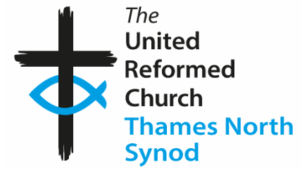 Hounslow URC May/June ’26 Newsletter 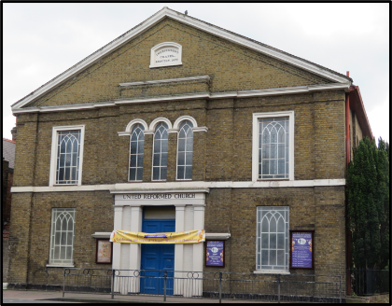
Hello everyone,
Family news
Please continue to pray for Kar Geh, Shirley, Alex, Mabel, Rachel (John’s wife) and her family.
Services for May, June and July
10th May – Rev. Maggie Hindley 24th May – Rev. Andrew Heron (H.C.)
14th June – Rev. Ian Gow 28th June – TBC
12th July – Rev. Andrew Heron 26th July – Rev. Ian Gow (H.C.)
Other dates for your diary (reminders):
Elders’ Meetings:
10th May, 12th July, 9th August, 11th October, 8th November, 13th December
Church Meetings:
14th June (AGM), 13th September
Other Dates
Saturday 4th July – Church Outing to Bognor Regis
Due to the increase in fuel prices, the price this year will be £25 per person (children free). A deposit of £10.00 per person will be collected from Sunday 10th May (by Tony).
Sunday 23rd August – Church tidy up and BBQ
Sunday 11th October – Harvest and shared lunch
Regarding the “Vacancy”, the Elders met with George Watt (Moderator) and we were told there is no one available. We looked at options such as training courses for Elders (to help with leading services) and some more names were suggested for people to help with services.
John’s Memorial
We were able to arrange for our Memorial Service for John to coincide with the visit by George Watt. We had a few visitors from other local churches and other groups who meet in our building. The service included tributes to John, some of his favourite hymns and a sermon where George including sharing some of his connections to John. It included Communion and was followed by lunch. Thanks to Neil for singing, Jane for playing, George for his words, those who contributed to the service, those who helped with the lunch, and Jo for the beautiful flowers. We made a sheet with tributes for John. We took a copy of this and some flowers to Rachel after the service. She said, “thank-you” to everyone. We are going to collect to buy a shrub for the garden in memory of John. This may have to wait until next year if it is the wrong time to plant. We will ask for contributions soon.
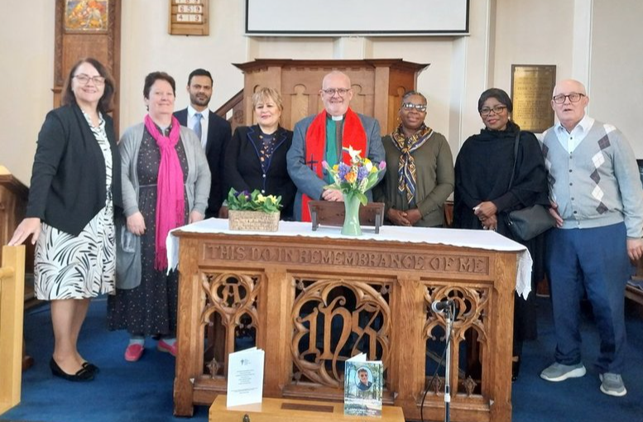
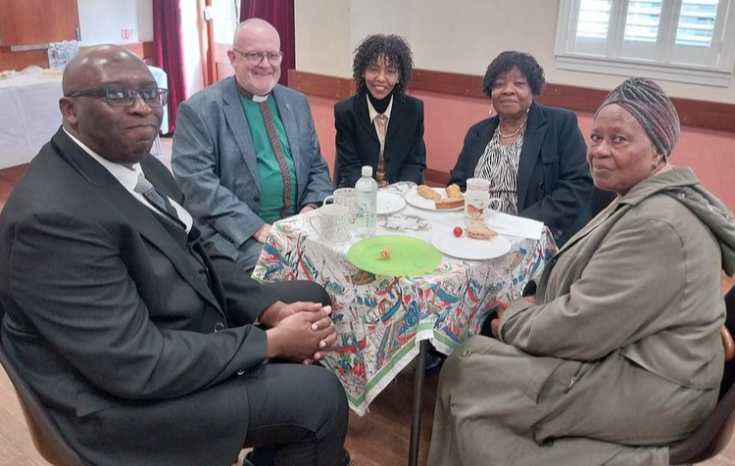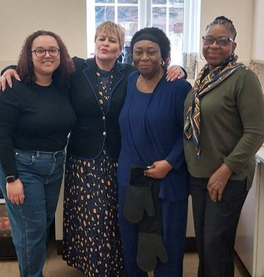
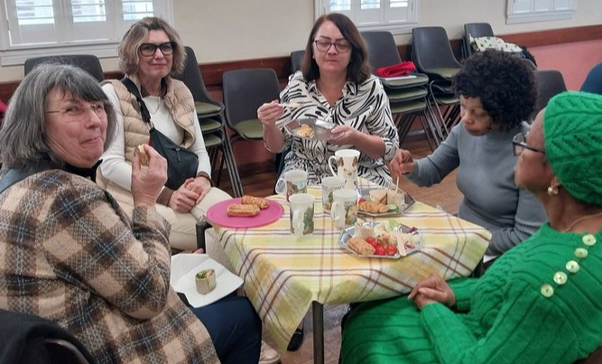
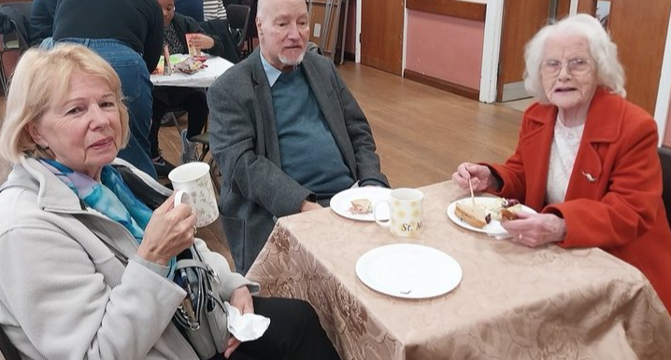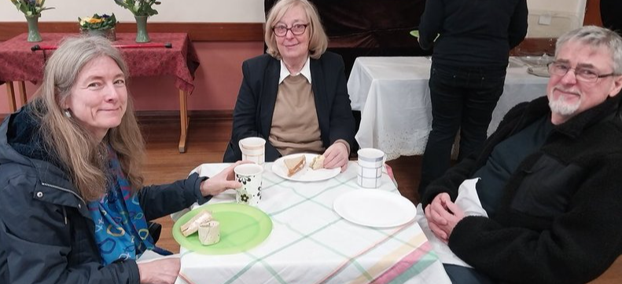
1926 – General Strike (4th- 12th May) – by Tony Fredjohn
This was the largest General Strike in British History. 1.2 million coal workers were locked out. They had been asked to take a 13% reduction in wages and work an extra hour per day. They were joined by many other workers but the miners continued alone until November when poverty forced them back to work and they had to reluctently accept the Government’s Terms. Hounslow Congregational Church were very supportive of the miners and next newsletter will include details of minutes from the Deacons’ and Finance Meeting of the church. On 9th May this year an event to commerate this is being celebrated in Hounslow and at this church. More details of events in 1926 will be included next time.

