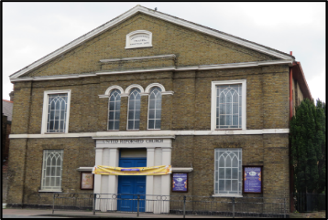
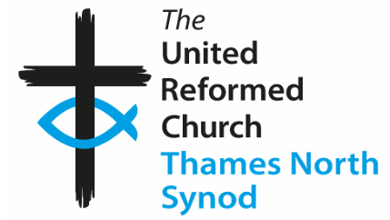 Hounslow URC March ’26
JOHN LATHAM
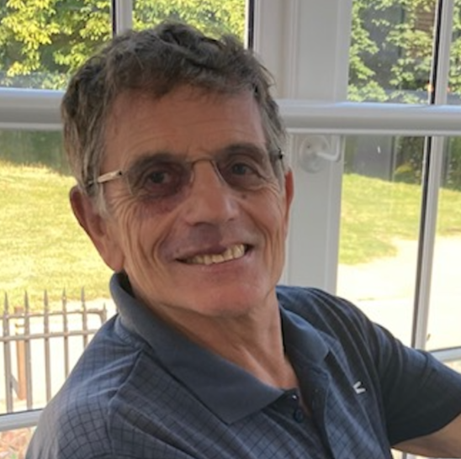
The seasons and patterns of our lives carry us through times of joy and times of sadness. At Hounslow URC, we have mourned the death of those who have been part of our journey. In February, we were saddened to hear of the death of John Latham, who over many years, was such an influential person in so many people’s lives.
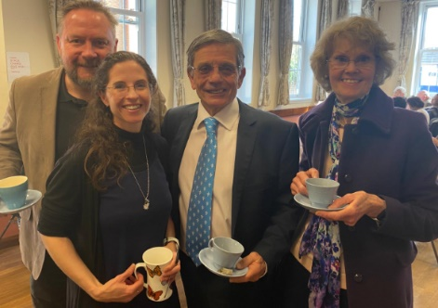
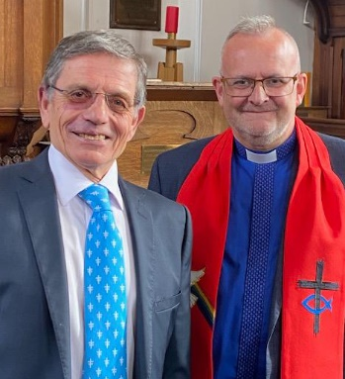
John was special to friends who he had known for a long time, and those he got to know more recently. John was a man of deep Christian faith, compassion, kindness and imagination. He was a loyal friend, a caring husband and father, and a more selfless person you could not meet. He met people where they were and was deeply committed to Hounslow URC, in spite of the continued commitment to his own local church. His influence reached out to many people and places. We at Hounslow will miss his leadership, friendship and commitment. Thank you, John.

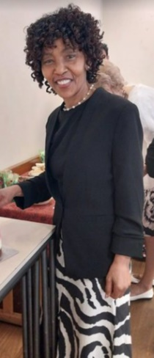
Tributes from friends at Hounslow URC

John served faithfully with us from 2009 to 2025 and was deeply respected and loved by the communities of Hounslow and Hampton URC, among many others. A true servant of God, he was compassionate, welcoming and inclusive to people of all ages, backgrounds and faiths. His preaching was engaging, often touched with humour, and always inspiring.
John’s passing leaves a great gap in our church and community and he will be greatly missed. On a personal note, he touched my life and the lives of my children, Ashton and Timothy from their Sunday School days, they still remember him fondly.
My thoughts and prayers are with his dear wife Rachel and all the family at this difficult time.
With much love, Anne

John came into our lives at Hounslow URC and he was most loving, caring and understanding. Any problem, he’d try, with understanding, to calm you down.
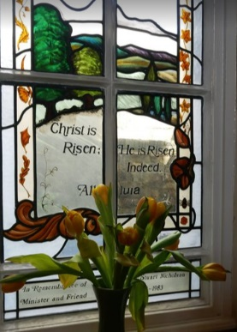
I returned from Ghana last September, after the funeral of my younger sister and got to know that, he had not been well with cancer and was not going to return to us any more. I sent him a message of well-wishings, followed by a missed call. He then returned my call with a beautiful response as to how many shots of chemo he had had and the progression. This happened a couple of times which was so reassuring. On 7th February, which was a Saturday, I sent him a message to check on him, but during the service the next day, his death was announced. This was a total shock to me and the rest of the congregation. All heads were down with tears.
John, rest peacefully and perfectly in the arms of your maker. Hopefully, we shall meet some day. Sleep well Phyllis

John was one of a kind. He made us feel special in his presence.
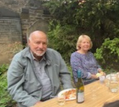
Bernard and I will always treasure the memories of his services. He made such an effort to make them special. I remember a service when he bought in ancient wheat for everyone to take home and grow or the time when he gave everyone a hand-made cross at Eastertime.
We will never forget his ministry at our church and as a Leader of Hounslow URC. Our thoughts and prayers are with Rachel and family at this sad time. Liz and Bernard

John has been a loyal servant and friend to this church. He has been a lay preacher here for
over 16 years, assisting with regular services and conducting special services and funerals.
Over the years, Elders and members grew to trust and respect him and admire his
commitment and dedication.
In 2022, the Elders met with Rev’d. George Watt, our moderator, to discuss our ministerial
vacancy. George suggested the idea of recruiting a Church Leader, and asked if there was
anyone that we knew who would be a good leader. The Elders all immediately thought of
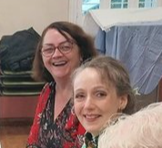
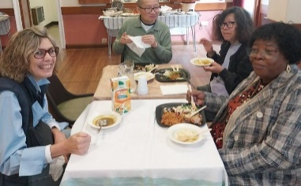
John, and later presented this proposal to a church meeting. Members unanimously approved the nomination. I phoned John to ask if he would be able to assist us and as always, he replied with great humility and kindness. He was keen to assist but said he needed to consult his dear wife Rachel first. John was such a respectful and devoted husband. One could clearly see the wonderful relationship they had as husband and wife. John and Rachel agreed to accept the calling and so 3 years ago, on 16th April 2023, we held a service of commissioning at HURC. John was officially inducted as our leader. Since then, he has been a wonderful champion for our church. John led services at least once a month, as well as extra services at Easter, Harvest and Christmas. He has been extremely supportive to Elders and members, offering pastoral care and genuine support. Personally, I have valued his support through periods of both grief and joy. John enabled me to take a sabbatical in 2024 so I could plan my daughter’s wedding abroad. He even offered to conduct the wedding ceremony when the minister cancelled at the last minute! I will truly miss him and his kindness. He was a true gentleman. Kathleen

Romans 14: 8 - If we live for the Lord, and if we die, we die for the
Lord. So, whether we live or die, we belong to the Lord.
May God bless you, and your family, today and always. Amen Elizabeth

It was a joy to have John as our Minister at Hounslow United Reformed Church. He was always so welcoming and attentive. He will be missed. RIP John. Jo
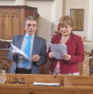
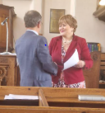
The last time I saw John was last September in Uxbridge. We chatted over church matters initially and then he dropped the bombshell that he had pancreatic cancer. With tears rolling down my eyes and heavy heart, I was extremely shocked to speak one word. My last words to him before he left for home, was to read Psalm 121, and I will be praying fervently for him. I was hoping for a miracle, but the sad news reached us on a Sunday morning. Words cannot describe the pain of losing such humble, kind-hearted and compassionate church leader. Pastor John, May your gentle soul RIPP. Nadya

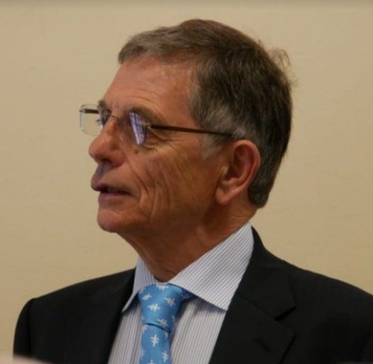
We cannot believe John was our Church Leader for such a short time! He was always kind and helpful and put himself out for others when he had time (and often when he didn’t). We were devastated to hear the news of his illness and missed his calming presence at our church. His leadership was selfless and we really appreciate his help and guidance, personally and at the church. He encouraged us all to do our best and was a guiding light during the services he led here. He valued our contributions and listened to our opinions. He took us in a new and welcome direction, but was also aware of our limitations.
Besides being fully committed to Hounslow he had a large leadership role at Hampton Hill URC and was fully committed to many projects there. He helped lead a playgroup, bereavement group, a choir (often being involved with founding them) and he preached there regularly. John still had much time available for family, gardening and walking in Bushy Park!
His preaching style was like no other! Engaging, entertaining and with a thoughtful, inspiring message. Thank you for your teaching.
It was lovely to hear news from him of Rachel and the rest of his family. John and Rachel were truly devoted to each other and we send our heartfelt prayers and love to her and the family at this time of sadness. Love from Jane and Tony
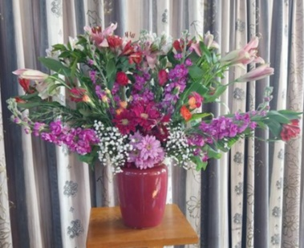
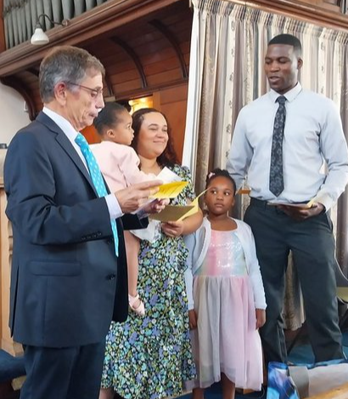
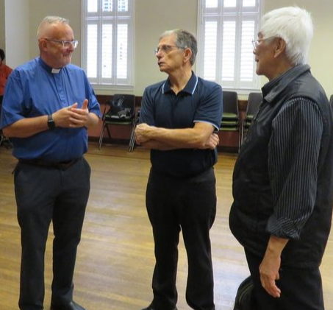

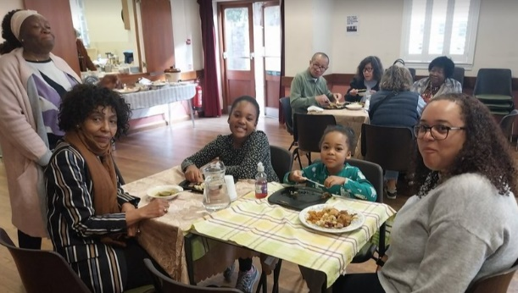

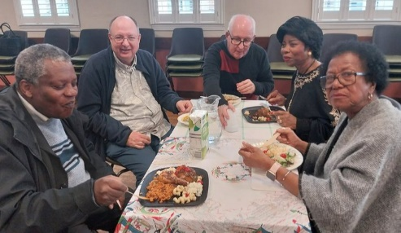

Sending all our love, prayers and best wishes from everyone at Hounslow URC.

