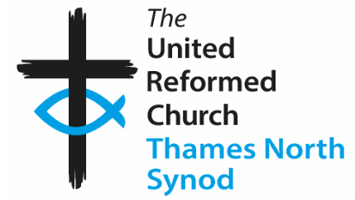 Hounslow URC January/February ’26 Newsletter 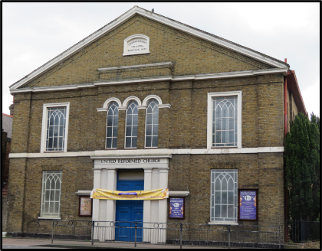
Greetings to you all and Happy New Year!
Apologies for the lateness of this Newsletter.
Family news
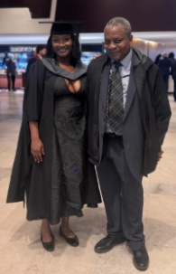
Please continue to pray for John, Mabel, Kar Geh, Shirley, Alex and Patrick.
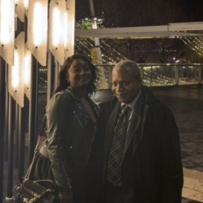
In November, Jackie celebrated her graduation at the University of Westminster. She obtained a Master’s Degree in Biochemical Science. Congratulations!

Aneima will be having a Wedding Celebration on 8th August, this year and will be having a Reception at the church afterwards.
Services for January, February and March
January 25th – Elders’ service February 8th – Elders’ service 22nd – TBC
March 8th – Rev. Simeon Sturney 22nd – Rev. George Watt (Moderator)
Meetings for the year: (January 11th – Elders)
Elders’ Meetings:
8th February, 12th April, 10th May, 12th July, 9th August, 11th October, 8th November, 13th December.
Church Meetings:
8th March, 14th June (AGM), 13th September
Notice will be given if any of the above meetings are cancelled or rescheduled.
Please be aware that we have started the process to have a “Vacancy” after John has left. The Elders will be meeting with the Moderator to look at options. We will let you know when we have more information.
Also, we would like to take the opportunity to recognise John Latham and his time with us. When George Watt takes the service in March (22nd), we would like to have some sort of celebration. We will invite John and Rachel to the service. They will come if John is well enough. If not, we will make some of record of the occasion to send to him.
Tony and I have been involved in an event to celebrate “International Women’s Day.” There will be an occasion at Holy Trinity (Hounslow) on Saturday 14th March from 9.45am until 12.00pm. Please ask for more details if you are interested.
Some more news. After the confusion on Remembrance Sunday (with road closures making it difficult for some to get to church), I made a complaint to the Council (to ensure that it doesn’t happen again). I have been invited to a meeting (hosted by Hounslow Royal British Legion) to plan the event for this year. Hopefully, I will be able to make sure that the views of Hounslow URC are voiced.
We had our own recognition of Remberance Sunday led by Maggie Hindley.

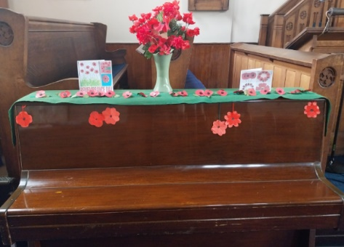
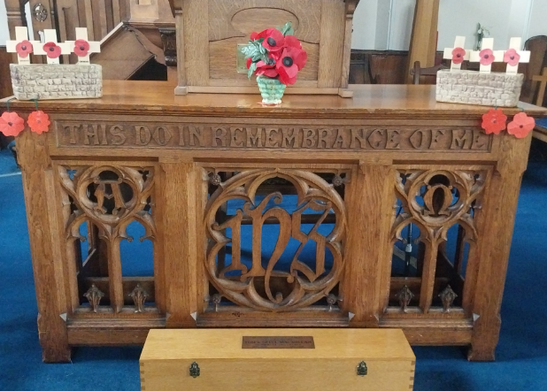

Outing to the Seaside and other events
We will be thinking about this soon. Please give any suggestions about venue or anything related to this to one of the Elders. This will be in June or July. We suggest the BBQ on Sunday 23rd August (1st Choice) or Sunday 26th July (2nd choice).
Harvest will be 11th October and will include a shared lunch.
For our Christmas celebration this year, we had a Nine Lessons and Carols service (led by the Elders). The church was decorated for the occasion. Thank you to Kathleen and Jo for this.
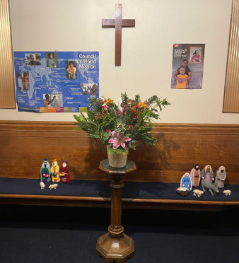
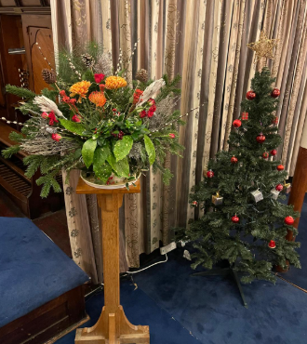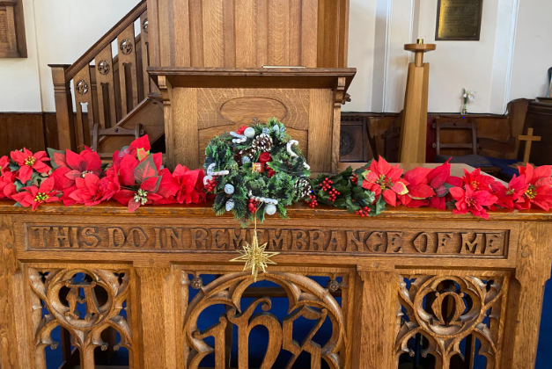
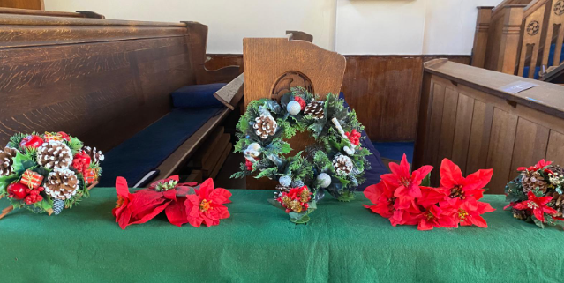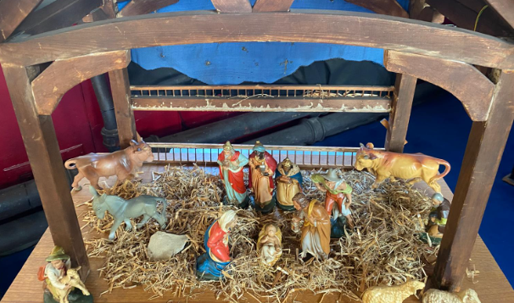
From March, Tony will be sharing with you some important events (relating to our church) from 1926.
Jane

