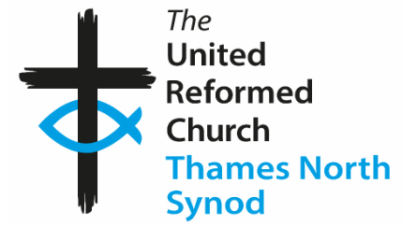 Hounslow URC January/February ’25 Newsletter 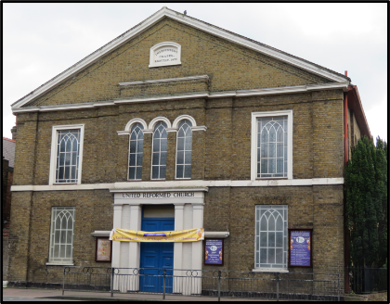
Happy New Year. This past year we have all benefitted from the support and encouragement our church friends have given us; each of us Is deeply grateful. For many in our congregation 2024 was a difficult year and to you we all send our love and prayers for 2025.
Looking forward, there are hopeful opportunities; not least in the simple signs of growth in most of the Christian fellowships who share our premises. God is praised and prayers are made. I feel our own congregation offers real hope, love and genuine joy. There were so many kind members offering to help in our traditional “Nine Lessons and Carol” service - thank you so much. Our leadership team - the Elders - needs to grow. Here too, members are generously offering their help. We have the chance to learn how we might lead worship; a short simple programme is being planned for anyone who might consider this. If you are interested, please let me know.
To help us feel more confident inviting friends or neighbours to ‘try us out’ it could be useful to outline the ‘headlines’ of services on January 12th and February 9th. In January the theme will be ‘Signs of hope and prayers for peace’. In February we will explore how, through acts of kindness, love can be shared. Are there people or situations where our prayers would be a support? Please drop me a note with your thoughts. Thank you.
Saturday morning coffee, cakes, even a gift stall; this was proposed with a spring time start date suggested. Here is an opportunity to ‘open our gates with praise’ on a Saturday morning, welcome neighbours and friends. Loneliness is a real issue in our hectic lives. A weekly social time can help. To set this up we are asking for volunteers to make up teams of three or four to host, run and support the initiative. Do you enjoy meeting new people and can give a couple of hours on a Saturday morning? Please ask me for more details.
The Lord builds the house. We are invited to invite others to Him. May the New Year bring us closer to one another and to the one we serve - Jesus Christ.
John Latham.
Important Dates:
Services for January, February and March
January 2025 - 12^{th -} John (followed by Church Meeting) 26/1/25 - Andrew Heron (HC)
February - 9th – John 23rd - Rev. Ian Gow (HC)
March – 9th Songs of Praise 23rd – John
Dates for the whole year will be published as soon as they become available.
Other News
As you are already aware, a serious incident happened in our church garden. We will be giving more news of this as soon as matters move forward. Other property matters will be discussed during the Church Meeting.
Summer Church Outing
During our church meeting on 12th January, we will be asking for suggested dates and venues. Please come with your diaries and ideas.
Some suggestions are: Brighton, Bournemouth and Hastings.
Hounslow United Reformed Church – 200 years of non-conformity (Independents, Congregationalists and Presbyterians)
As the anniversary year has now come to an end, there will be a break from these articles this time. We will now concentrate on the building which celebrates 190 years this year. For this reason, the exhibition will remain and be added to during 2025.
Jane

